ROYAL OAK INTERNATIONAL SCHOOL
SR. SEC. CBSE AFFILIATED
WORKSHEET (2018-2019)
(Know your computer, Computer a smart machine)
Subject: Computer Class: I Sec.________ Name:__________________ Roll No:-__
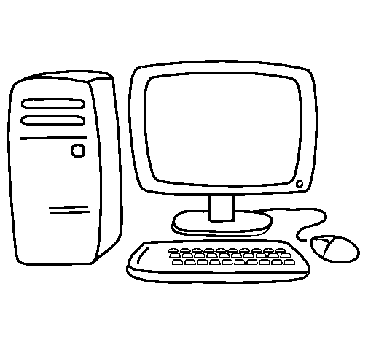
Q1. Write the name of the parts of the computer:-

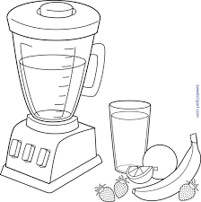
Q2. Identify the picture and write the name of these machines:-
a)
I give you fresh juice of oranges.
__________________________

b) I take you from place to another place
___________________________
c)
I show you cartoon movies
___________________________

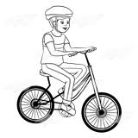
Q3. Tick (√ ) the correct option on which the following machines work:-
a) Human power
Fuel
Electricity

b) Human power
Fuel
Electricity

Q4. Read the following statements carefully. Put a (√ ) for True and cross(X) for the False statement:-
a) Computer is a God made machine.
b) Computer can draw cartoons.
c) Computer works at slow speed.
d) Computer can pack your lunch for school.
e) Computer can play outdoor games with you.
Q5. Cross (x) the incorrect words to form correct statement:-
breathe.
calculate.
Living
Non -living
a) Computer is thing and it can not

Lunch box.
Orders.
fuel
electricity
b) Computer works with and need your

Slow.
Fast.

God
Humans
c) Machines are made by and works very

Q6.Tick (√) the correct option for the pictures given below:-
a) b)
Natural thing Natural thing
Man-Made thing Man-Made thing
Q7. Answer the following questions:-
a) Write the name of any two machines which entertain us.
Ans:- 1._____________________________
2._____________________________
b) Write any two qualities of computer.
Ans:-1.__________________________________________
2.__________________________________________
c) Write the name of any two machines that works on electricity.
Ans:- 1._____________________________
2._____________________________
d) Write the name of any two machines which works on fuel.
Ans:- 1._____________________________
2._____________________________
Q8. Fill in the blanks with the help of words given in the help box:-
[ color , memory , fast , add]
- Computer works very_________.
- Computer can draw and ____________ pictures.
- Computers can __________ numbers.
- Computer has large ____________ to save work.
Q9. Complete the web using words in the helping box:-
send e-mail, create music, play games, print words, Calculations

a) can ___________________ b) can ___________________ c) can ___________________
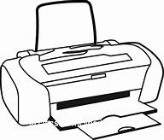
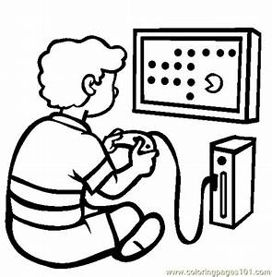

COMPUTER

d) can ___________________ e) can ___________________

